Daniel Allison

danielallison77@gmail.com

n01465744

Assignment 1

CCGC 5502 Automation – Humber College

Table of Contents

**Phase 1: Development** 4

Setup 4

GitHub Repo 4

Cocogitto 5

backend.tf and providers.tf 6

terraform init 7

Project Metadata (root variables.tf) 8

Resource Group Child Module 9

Definition 9

Dev Test: Validation, Provisioning, Verifying in Azure Portal 10

Release 11

Network Child Module 12

Definition 12

Dev Test: Validation, Provisioning, Verifying in Azure Portal 15

Release 16

Common Child Module 17

Definition 17

Dev Test: Validation, Provisioning, Verifying in Azure Portal 20

Release 21

Linux Child Module 21

Definition 21

Dev Test: Validation, Provisioning, Verifying in Azure Portal 28

Release 29

Table of Figures

SCREENSHOT 1: The mostly empty initialized code repository in GitHub 3

SCREENSHOT 2: cog.toml, the configuration file for cocogitto, a conventional commits tool 4

SCREENSHOT 3: backend.tf and providers.tf 5

SCREENSHOT 4: terraform init and then again with migrate state to the new backend tfstate key 6

SCREENSHOT 5: variables.tf in the root module showing the project_metadata variable, used for tagging every resource 7

SCREENSHOT 6: the resource group child module’s main.tf, variables.tf, and outputs.tf 8

SCREENSHOT 7: terraform validate shows valid configuration for newly added resource group 9

SCREENSHOT 8: terraform state list | nl shows the deployed resource group 9

SCREENSHOT 9: Azure Portal shows the assignment1.tfstate after resource group deployed 9

SCREENSHOT 10: Azure Portal shows deployed resource group with tags 10

SCREENSHOT 11: the network child module's main.tf, with a vnet, subnet, nsg, and net sec rules 11

SCREENSHOT 12: network child module’s variables.tf with variables for vnet, subnet, nsg, local module and project metadata 12

SCREENSHOT 13: network child module's outputs.tf with vnet and subnet names 13

SCREENSHOT 14: terraform validate shows valid configuration for newly added network module 14

SCREENSHOT 15: terraform state list shows 9 resources deployed after network module added 14

SCREENSHOT 16: Azure Portal shows assignment1.tfstate after network module deployed 14

SCREENSHOT 17: Azure Portal shows deployed network security group with open ports 22, 3389, 5985, and 80 15

SCREENSHOT 18: Common child module's main.tf including log analytics workspace, recovery services vault, and storage account 16

SCREENSHOT 19: local module variable, variables for resource group, log analytics workspace, recovery services vault, storage account, and project metadata 17

SCREENSHOT 20: common child module’s outputs.tf returns log analytics workspace name, recovery services vault name, and storage account name 18

SCREENSHOT 21: terraform validate shows valid configuration for newly added common module 19

SCREENSHOT 22: terraform state list | nl shows 12 deployed resources including newly added log analytics workspace, recovery services vault, and storage account 19

SCREENSHOT 23: Azure Portal shows assignment1.tfstate showing the last lines of deployed resources 19

SCREENSHOT 24: Azure Cloud Shell shows a PowerShell command that identifies CentOS 8.2 offerings from OpenLogic 20

SCREENSHOT 25: Azure Cloud Shell shows a PowerShell command that identifies the version number for CentOs 8_2-gen2 20

SCREENSHOT 26: Azure Cloud Shell shows PowerShell commands being run to find out the virtual machine extensions' types, versions, and publisher 20

SCREENSHOT 27: the linux child module's main.tf, lines 1-64 21

SCREENSHOT 28: linux child module's main.tf, lines 65-118 22

SCREENSHOT 29: linux child module's main.tf, lines 118-134 23

SCREENSHOT 30: linux child module's variables.tf, lines 1-66 24

SCREENSHOT 31: linux child module's variables.tf lines 67-108 25

SCREENSHOT 32: linux child module's outputs.tf 26

SCREENSHOT 33: linux child module's provisioner.tf 26

SCREENSHOT 34: terraform validate shows configuration is valid after linux child module added 27

SCREENSHOT 35: terraform state list | nl shows 25 deployed resources after linux module added 27

SCREENSHOT 36: Azure Portal shows deployed resources after linux module added 28

# **Phase 1: Development**

## Setup

### GitHub Repo

The first step I took to start this assignment was to create a GitHub repository in which the code could be stored and shared. It was initialized with a Terraform specific .gitignore and a README.md file.

SCREENSHOT 1: The mostly empty initialized code repository in GitHub

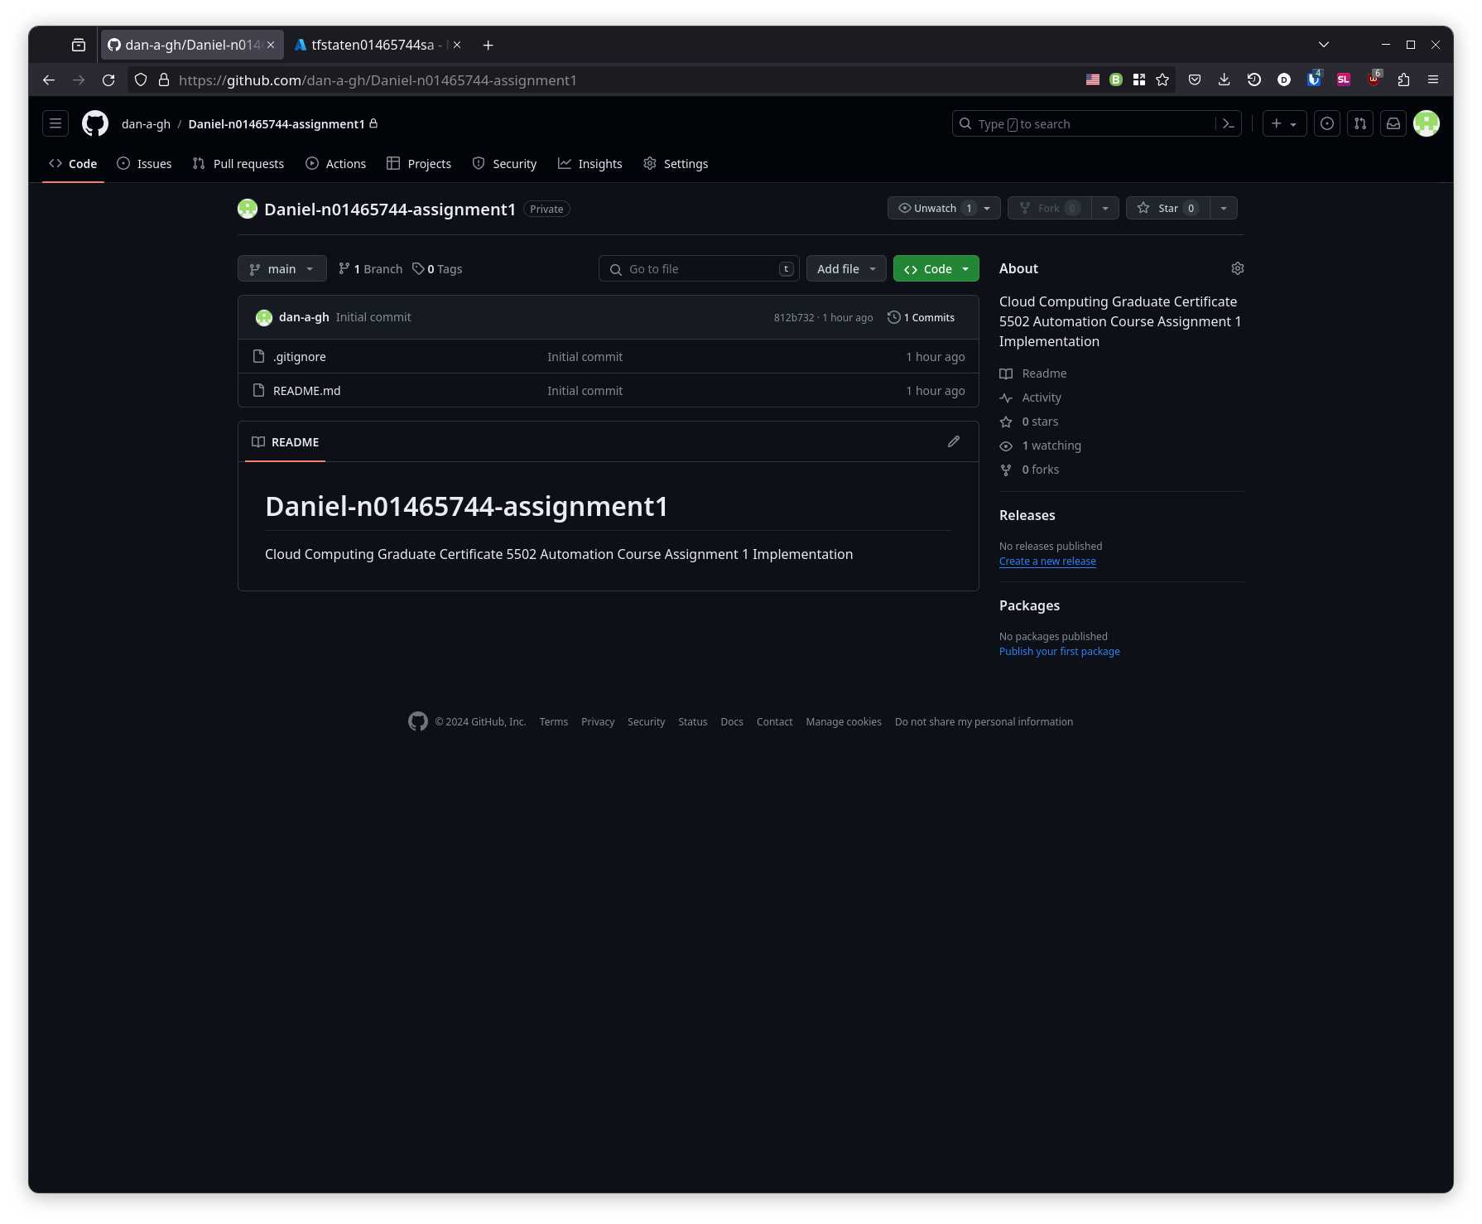

### Cocogitto

Cocogitto is a tool to create conventional commits, which is a standard to help organize git commit messages. It can also manage versioning based on what type of work was identified in the commit messages since the last version was tagged. Since I already had the tool installed, setup involved running the command cog init, and filling out the cog.toml configuration file with commands that use git hooks to run before/after bumping the version number.

SCREENSHOT 2: cog.toml, the configuration file for cocogitto, a conventional commits tool

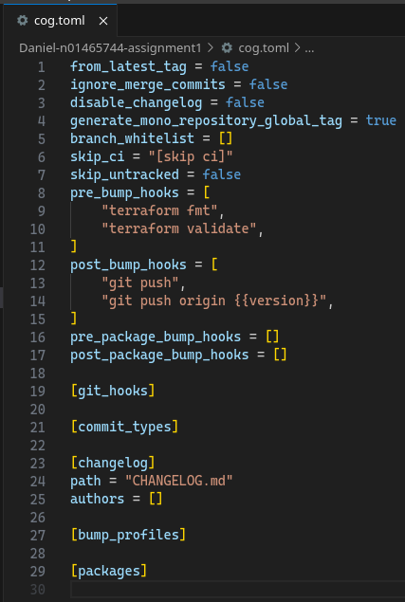

### backend.tf and providers.tf

The backend.tf and providers.tf files were next to be created. I drew heavy inspiration from work performed in lab 05. I changed the name of the key once I realized that it was going to overwrite tfstate from the labs if no changes were made.

SCREENSHOT 3: backend.tf and providers.tf

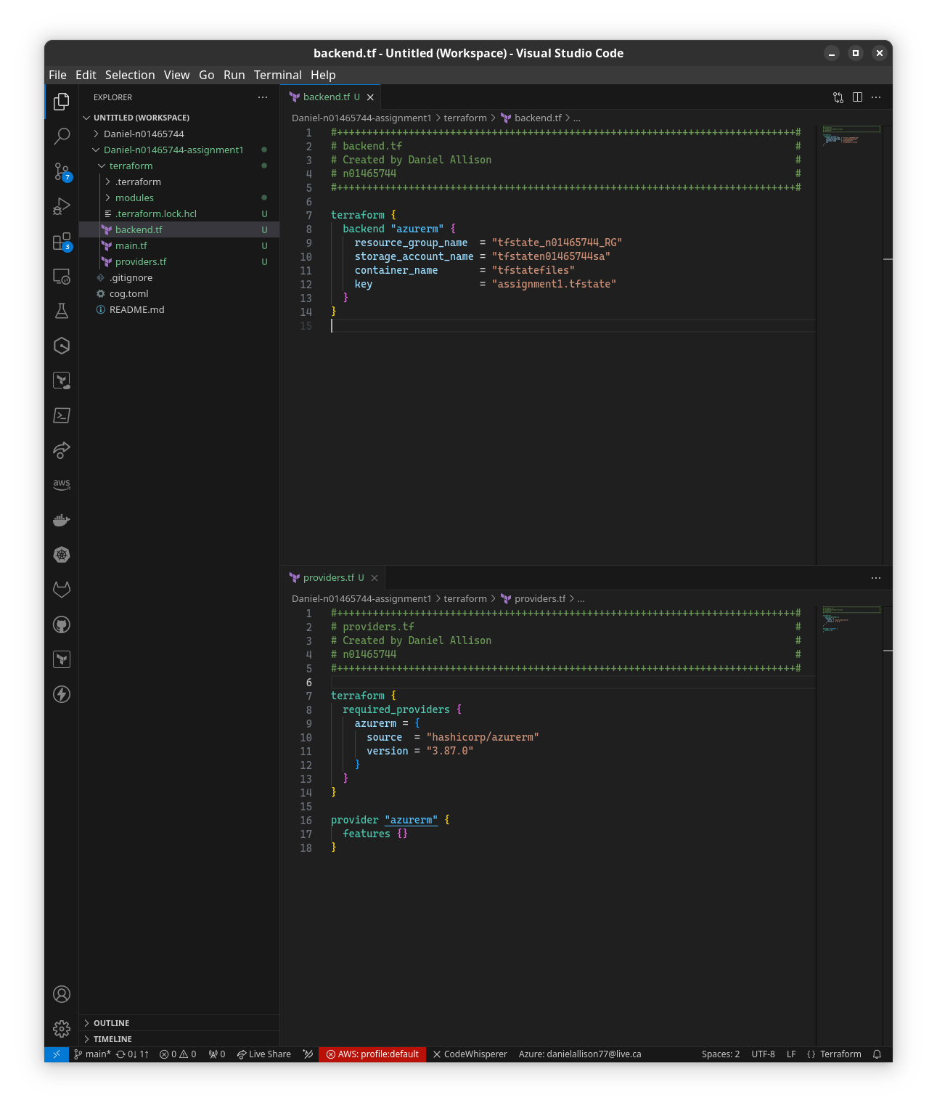

### terraform init

With the bare minimum files in place to initialize, I went ahead and tested my code with terraform init. The first time was with the old key tfstate that would have overwritten the labs work, the second successful time with the migrate state option uses the new backend tfstate key.

SCREENSHOT 4: terraform init and then again with migrate state to the new backend tfstate key

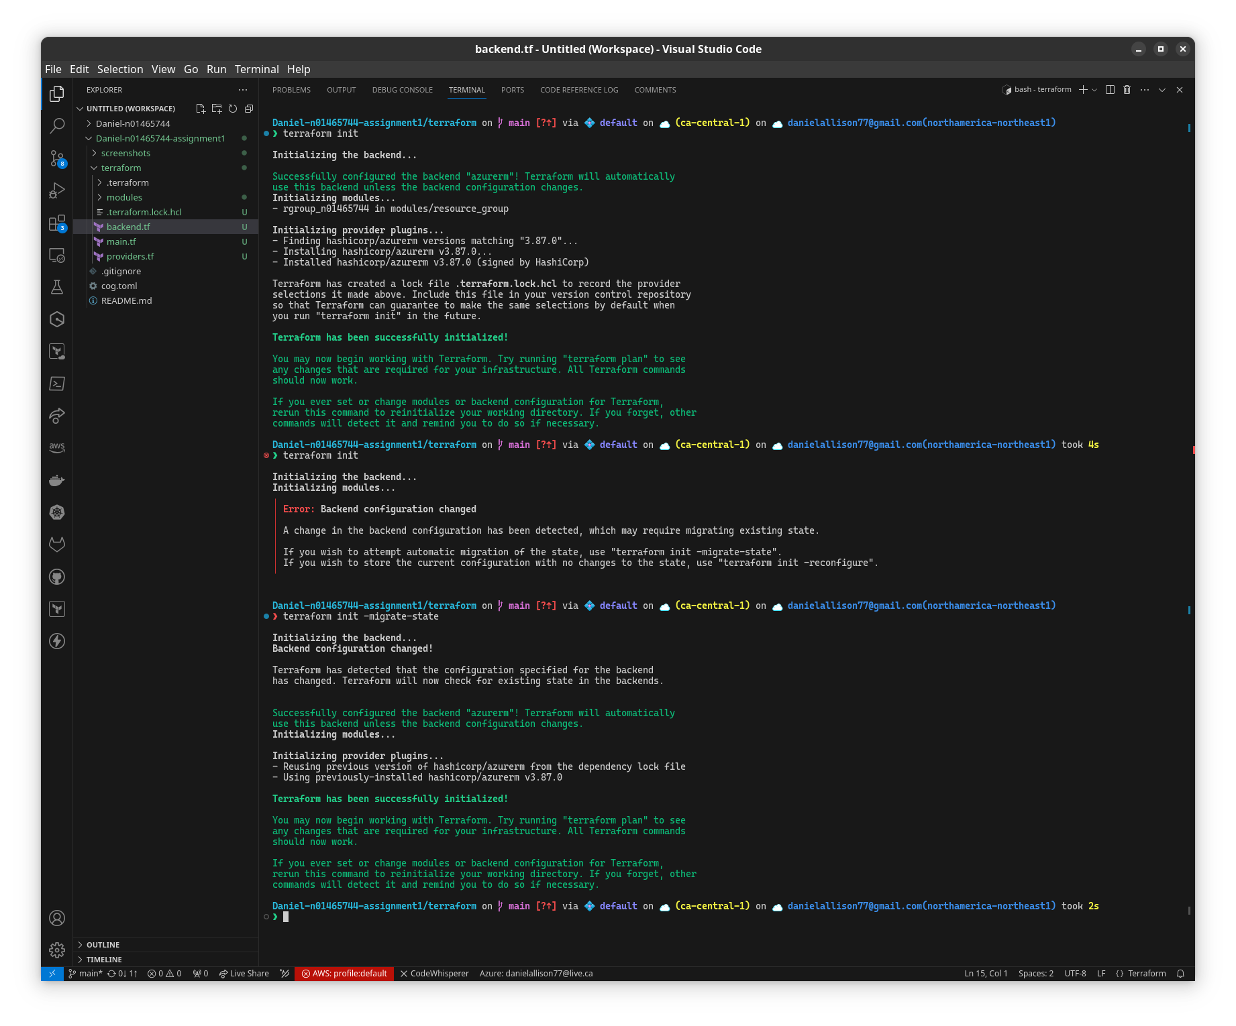

### Project Metadata (root variables.tf)

For the data used in tags common to all resources, I have created a variables.tf at the root level with one object variable called “project_metadata”. I chose this approach over using locals because locals are meant to be used within a module, like a function’s temporary local variables in traditional programming languages.[1]

SCREENSHOT 5: variables.tf in the root module showing the project_metadata variable, used for tagging every resource

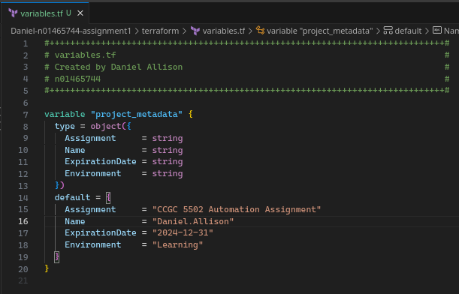

## Resource Group Child Module

### Definition

The resource group resource is defined in main.tf with parametrized fields, tagged with project metadata, corresponding variables are declared in variables.tf, and outputs.tf returns the resource group name.

SCREENSHOT 6: the resource group child module’s main.tf, variables.tf, and outputs.tf

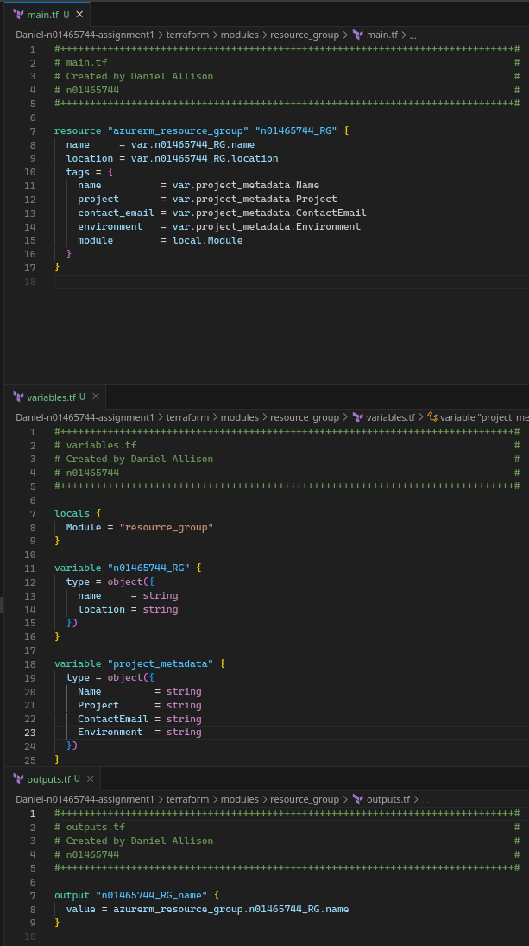

### *Dev Test: Validation, Provisioning, Verifying in Azure Portal*

This module was tested with terraform validate, plan, and deploy.

SCREENSHOT 7: terraform validate shows valid configuration for newly added resource group

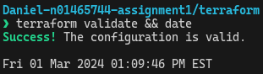

SCREENSHOT 8: terraform state list | nl shows the deployed resource group



The resource group was verified as deployed in Azure Portal.

SCREENSHOT 9: Azure Portal shows the assignment1.tfstate after resource group deployed

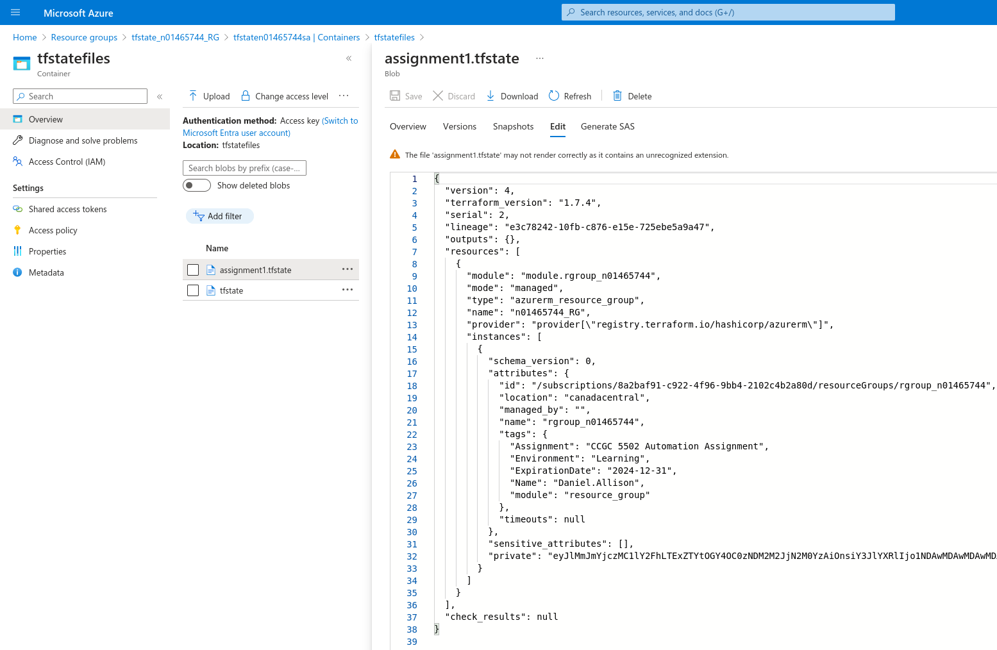

SCREENSHOT 10: Azure Portal shows deployed resource group with tags

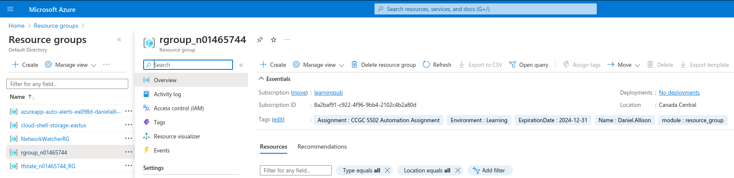

### Release

The resource group child module was released in version 0.1.0.

## Network Child Module

### Definition

The virtual networking, subnet, network security group, network security rule, and subnet network security group association resources are defined in main.tf with parametrized fields, and tagged with project metadata.[2]

SCREENSHOT 11: the network child module's main.tf, with a vnet, subnet, nsg, and net sec rules

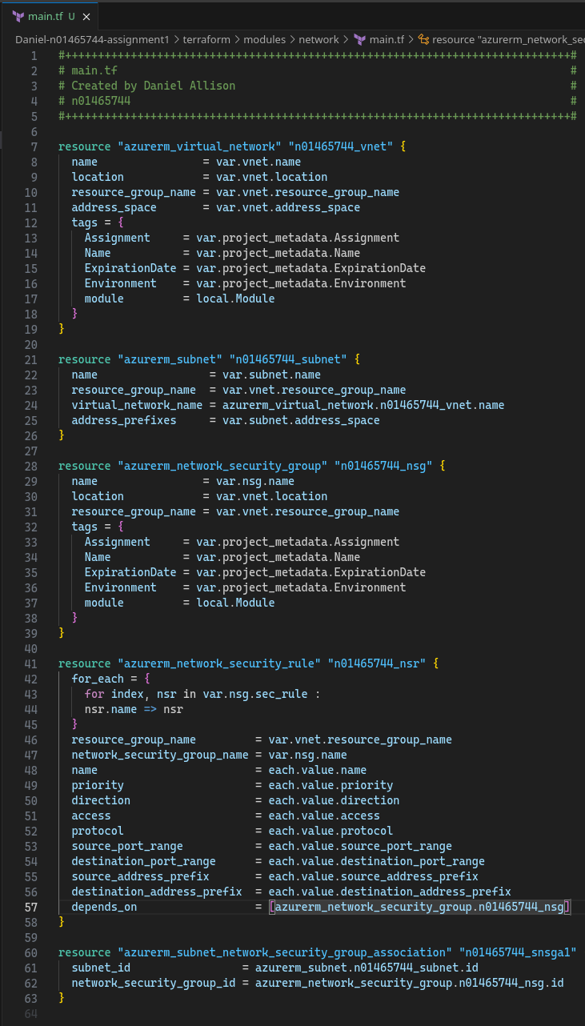

The corresponding variables are declared in variables.tf.

SCREENSHOT 12: network child module’s variables.tf with variables for vnet, subnet, nsg, local module and project metadata

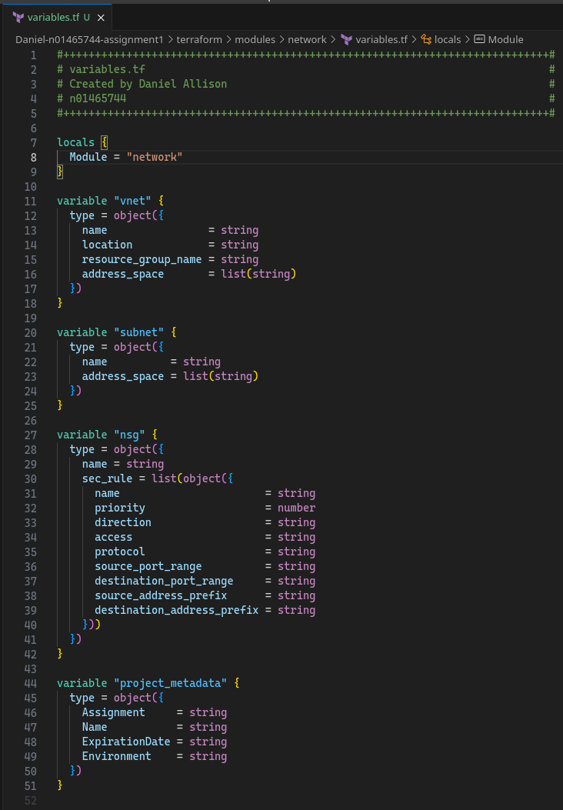

outputs.tf returns the names of the virtual network and subnet to the root module.

SCREENSHOT 13: network child module's outputs.tf with vnet and subnet names

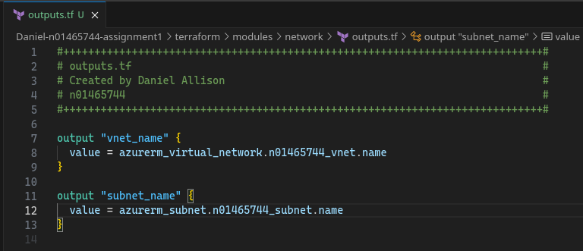

### *Dev Test: Validation, Provisioning, Verifying in Azure Portal*

This module was tested with terraform validate, plan, and deploy.

SCREENSHOT 14: terraform validate shows valid configuration for newly added network module

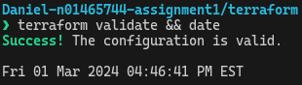

SCREENSHOT 15: terraform state list shows 9 resources deployed after network module added

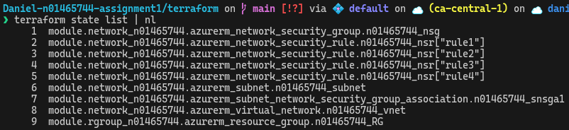

SCREENSHOT 16: Azure Portal shows assignment1.tfstate after network module deployed

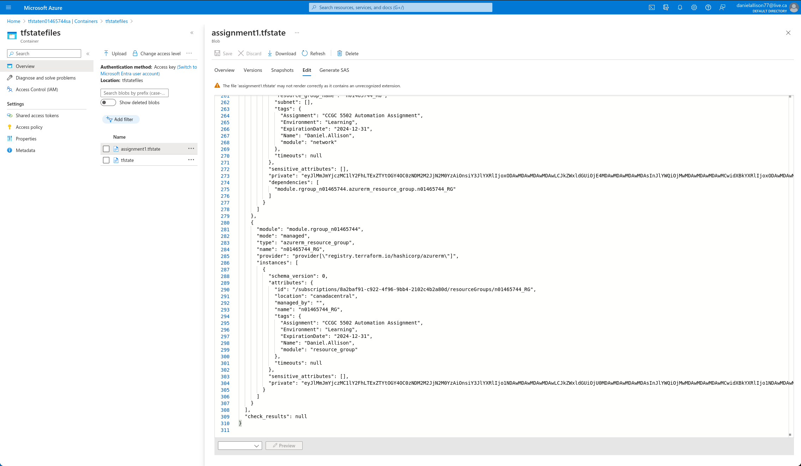

SCREENSHOT 17: Azure Portal shows deployed network security group with open ports 22, 3389, 5985, and 80

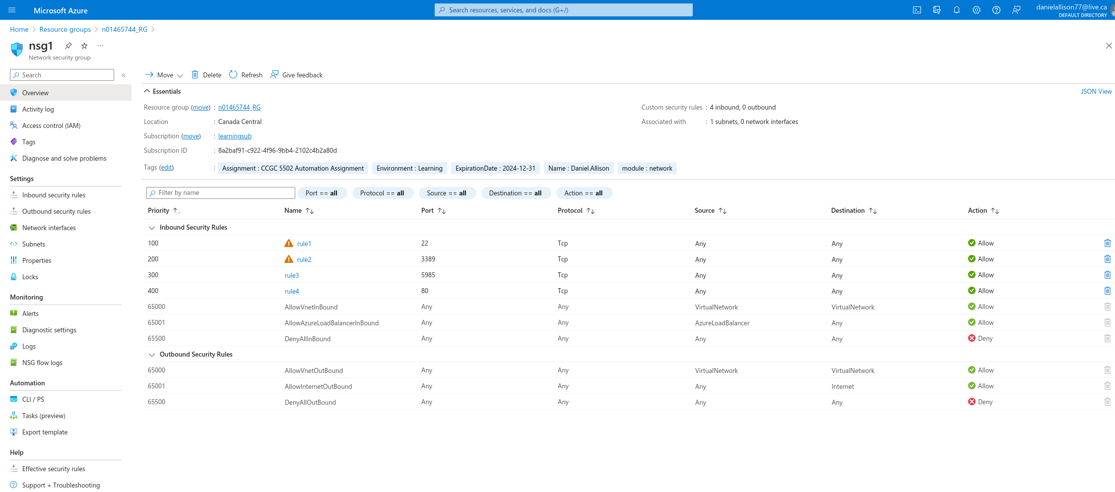

### Release

The network child module was released in version 0.2.0.

## Common Child Module

### Definition

The log analytics workspace, recovery services vault, and storage account are defined in main.tf with parametrized fields, and tagged with project metadata.

SCREENSHOT 18: Common child module's main.tf including log analytics workspace, recovery services vault, and storage account

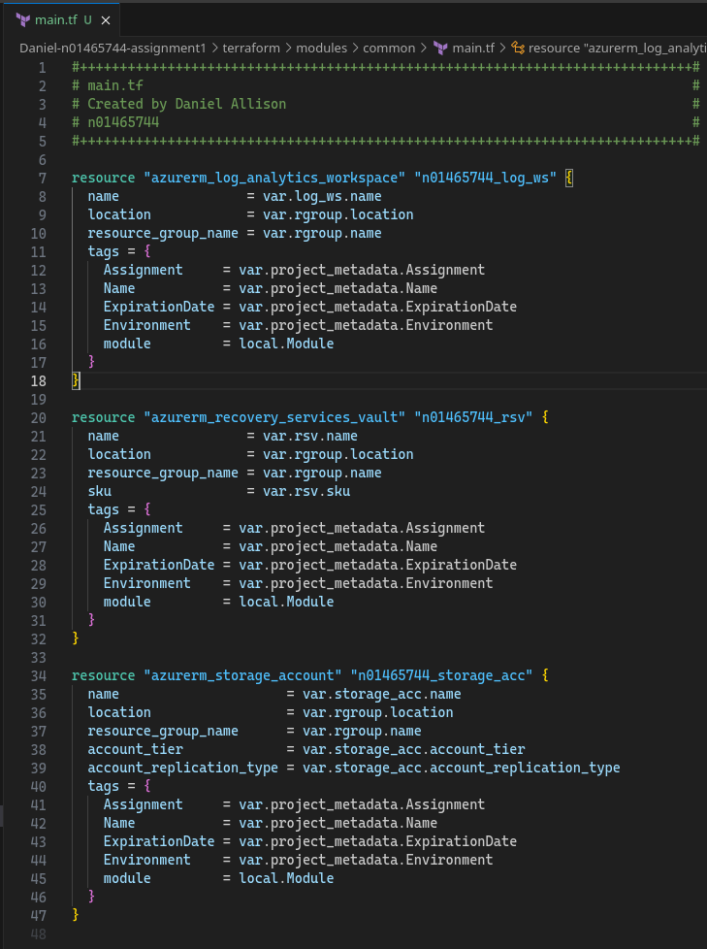

The corresponding variables are declared in variables.tf.

SCREENSHOT 19: local module variable, variables for resource group, log analytics workspace, recovery services vault, storage account, and project metadata

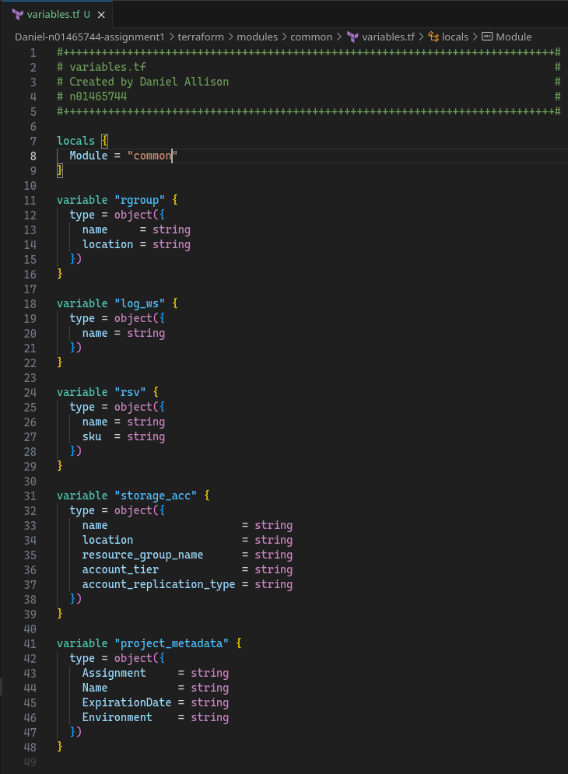

SCREENSHOT 20: common child module’s outputs.tf returns log analytics workspace name, recovery services vault name, and storage account name

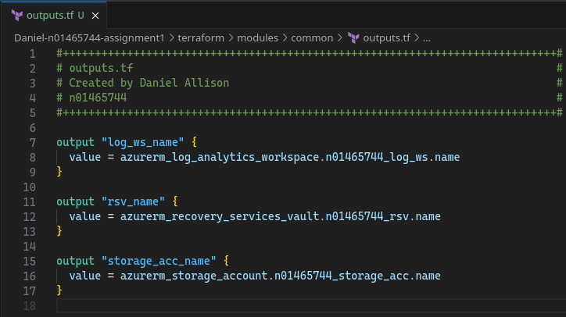

### Dev Test: *Validation, Provisioning, Verifying in Azure Portal*

This module was tested with terraform validate, plan, and deploy.

SCREENSHOT 21: terraform validate shows valid configuration for newly added common module

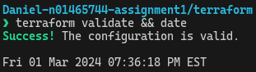

SCREENSHOT 22: terraform state list | nl shows 12 deployed resources including newly added log analytics workspace, recovery services vault, and storage account

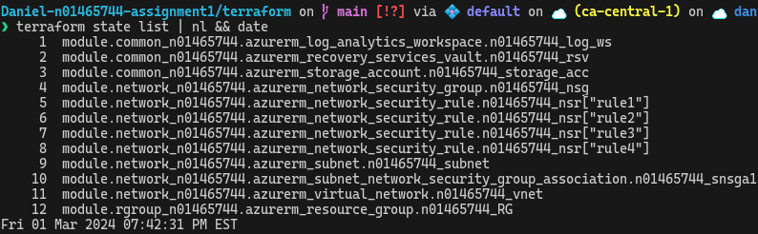

SCREENSHOT 23: Azure Portal shows assignment1.tfstate showing the last lines of deployed resources

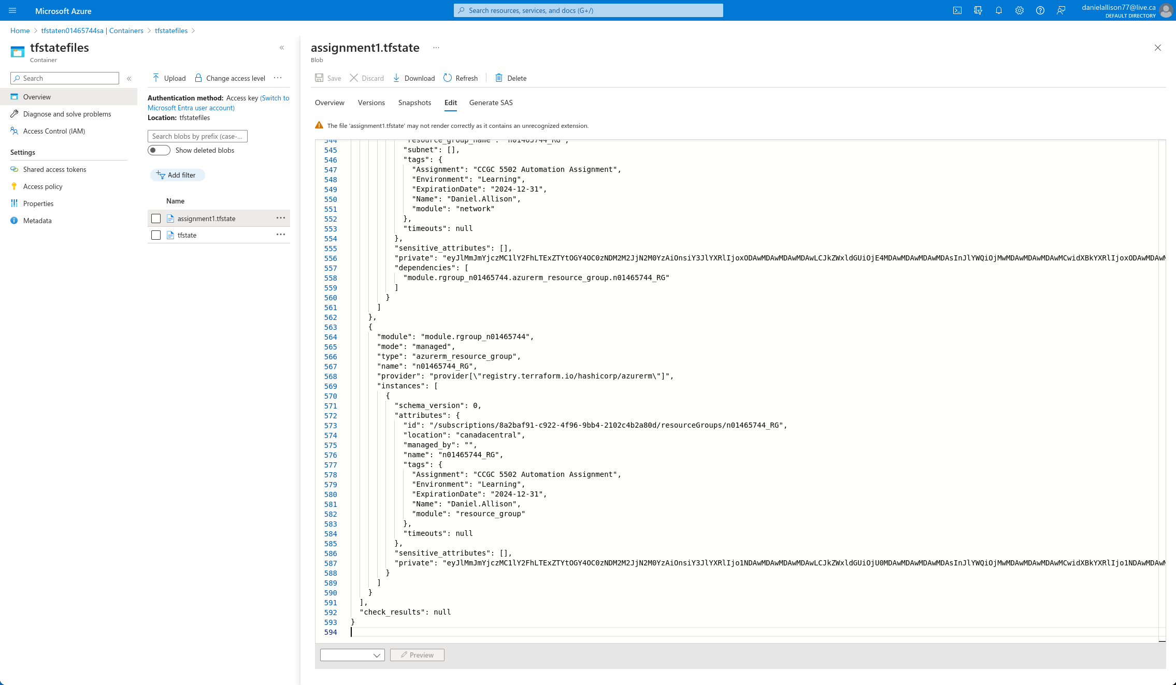

### Release

The common child module was released in version 0.3.0.

## Linux Child Module

### Definition

In order to deploy a CentOS virtual machine, a suitable offering needed to be found from the Azure Marketplace. Microsoft maintains a list of endorsed Linux distributions[3], which is a good place to start to look for CentOS offering. OpenLogic by Perforce, formerly RogueWave, maintains several images. Using the following PowerShell command in Azure Cloud Shell, two candidates were identified:

SCREENSHOT 24: Azure Cloud Shell shows a PowerShell command that identifies CentOS 8.2 offerings from OpenLogic



8_2-gen2 was picked. This next command identified the version number of the latest version:

SCREENSHOT 25: Azure Cloud Shell shows a PowerShell command that identifies the version number for CentOs 8_2-gen2



The virtual machine extensions required some extra care to figure out an acceptable value for the type_handler_version. The following PowerShell commands were run[4] in Azure Cloud Shell to find information about the latest versions of the Monitor and Network Watch extensions.

SCREENSHOT 26: Azure Cloud Shell shows PowerShell commands being run to find out the virtual machine extensions' types, versions, and publisher

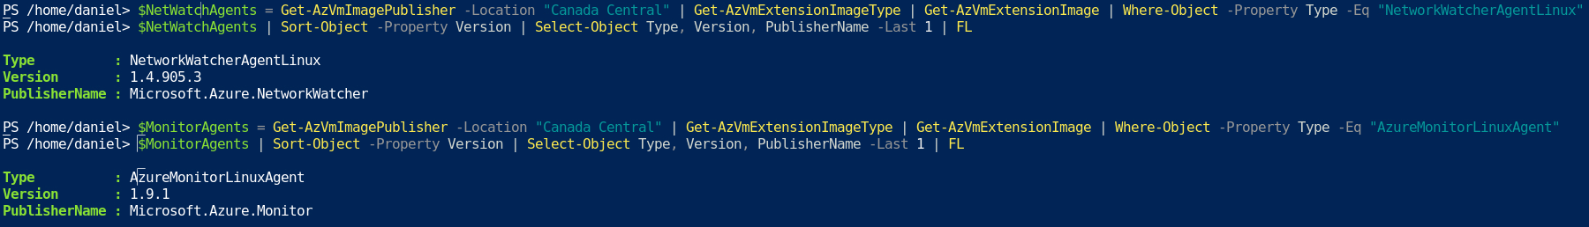

Terraform won’t accept those version numbers unmodified though. They must be truncated to major.minor only.[5] This was not clear in the terraform documentation.[6]

SCREENSHOT 27: the linux child module's main.tf, lines 1-64

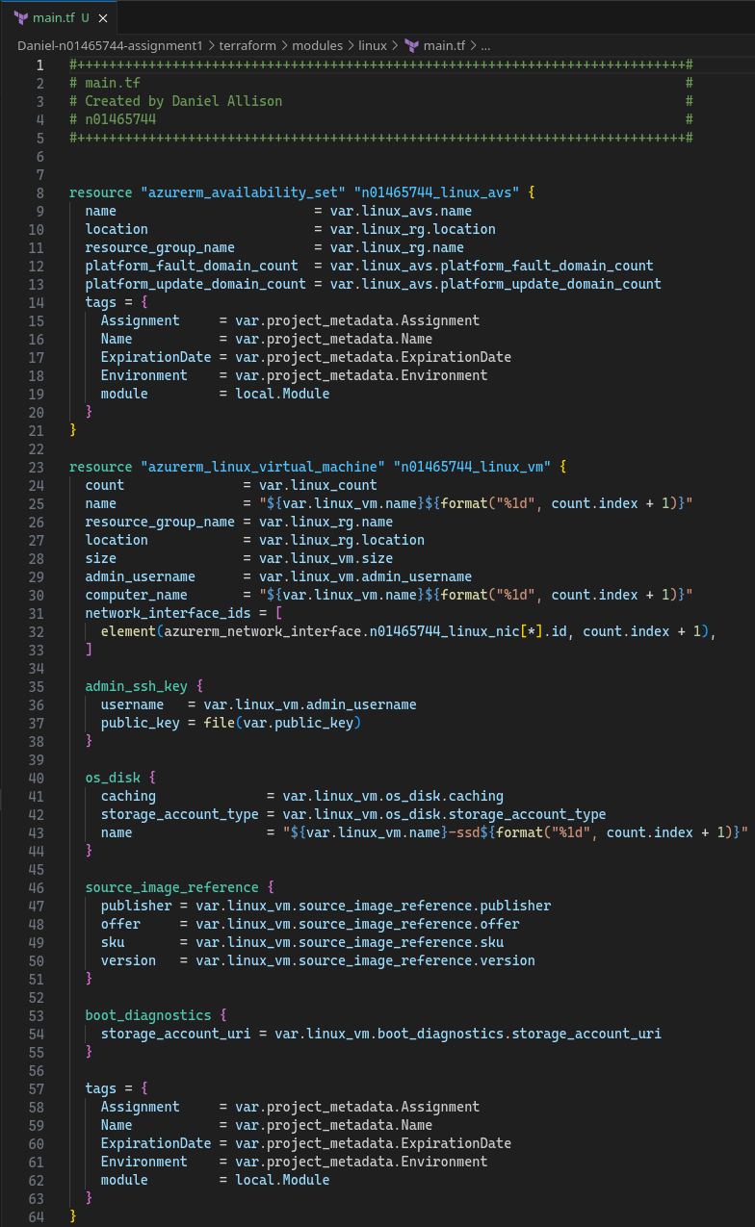

SCREENSHOT 28: linux child module's main.tf, lines 65-118

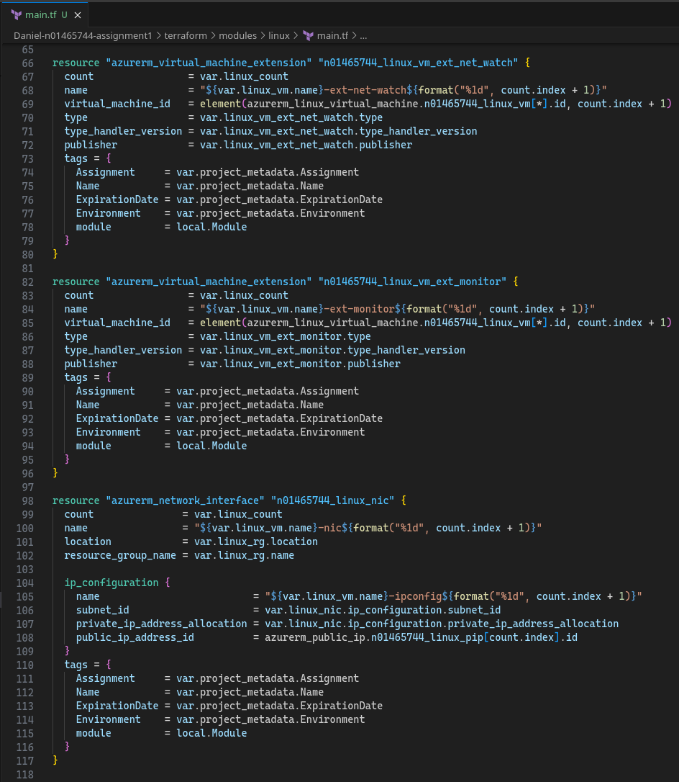

SCREENSHOT 29: linux child module's main.tf, lines 118-134

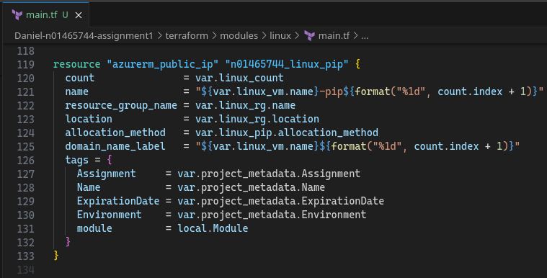

SCREENSHOT 30: linux child module's variables.tf, lines 1-66

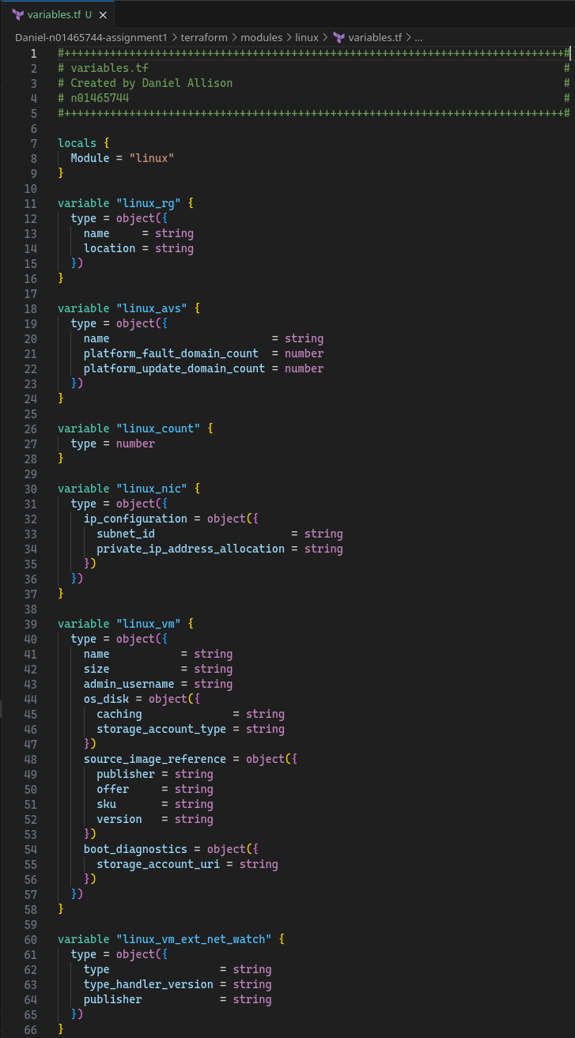

SCREENSHOT 31: linux child module's variables.tf lines 67-108

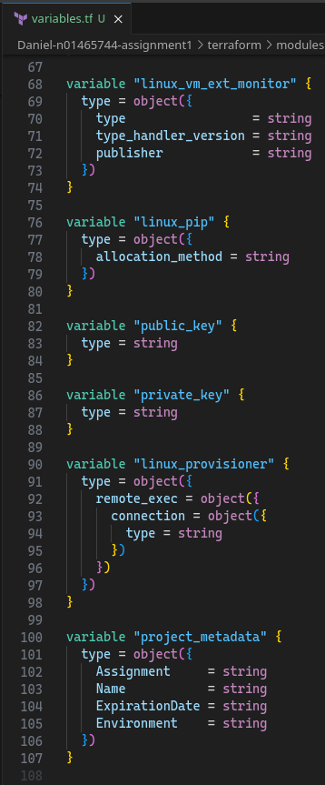

SCREENSHOT 32: linux child module's outputs.tf

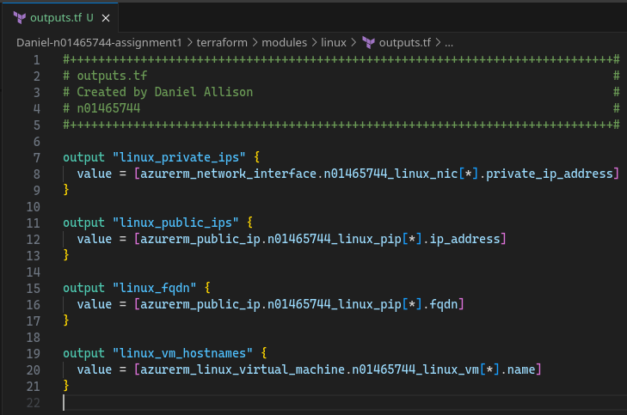

SCREENSHOT 33: linux child module's provisioner.tf

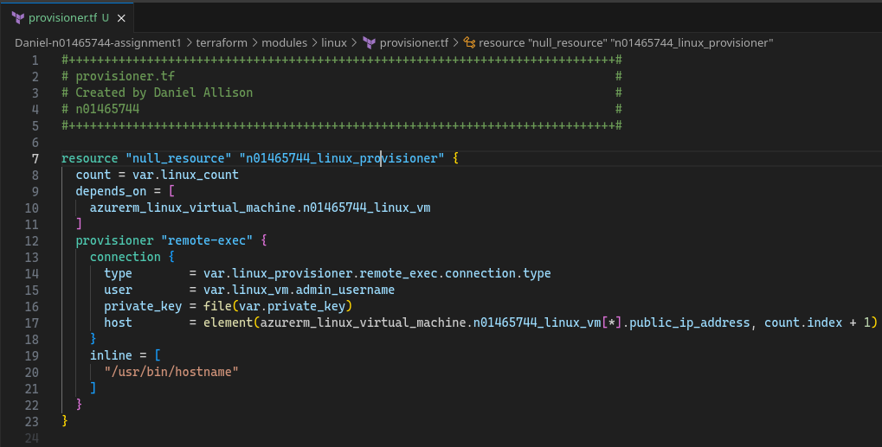

### Dev Test: *Validation, Provisioning, Verifying in Azure Portal*

This module was tested with terraform validate, plan, and deploy.

SCREENSHOT 34: terraform validate shows configuration is valid after linux child module added

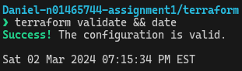

SCREENSHOT 35: terraform state list | nl shows 25 deployed resources after linux module added

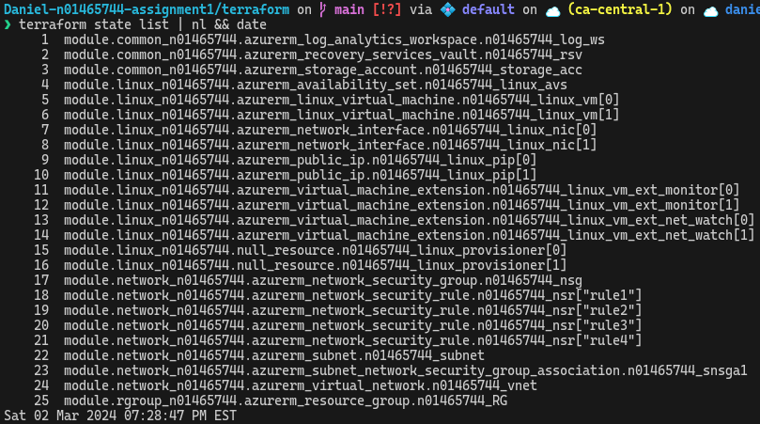

SCREENSHOT 36: Azure Portal shows deployed resources after linux module added

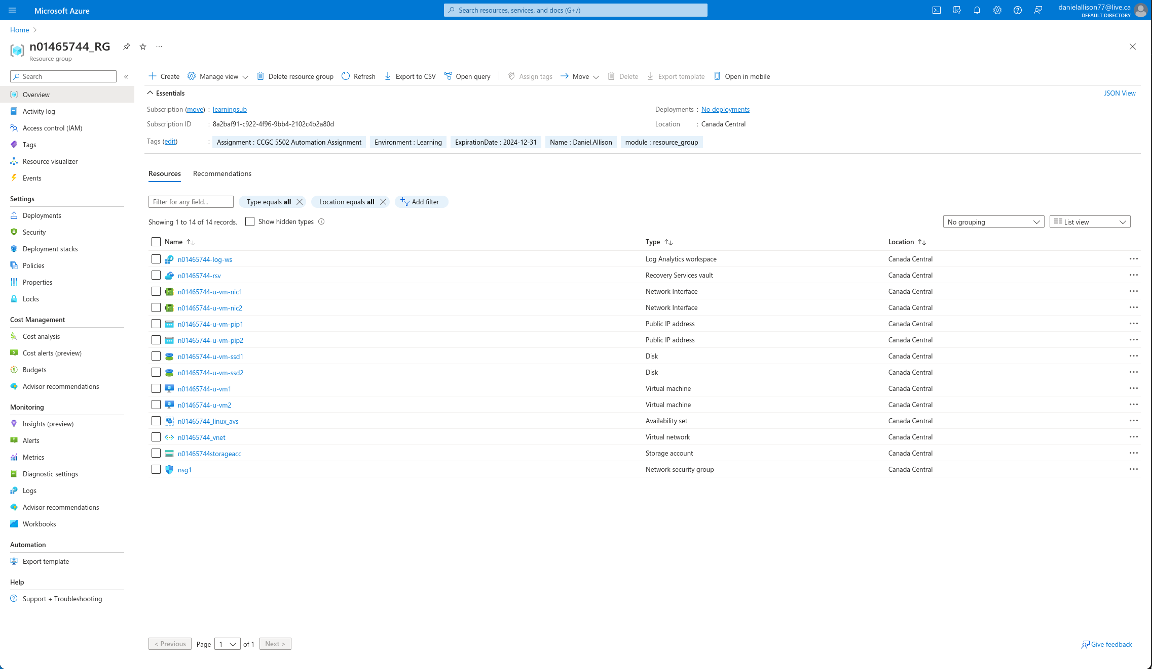

### Release

The linux child module was released in version 0.4.0.

1. https://developer.hashicorp.com/terraform/language/values/locals
2. Inspiration for for_each iterating over objects taken from this StackOverflow answer: https://stackoverflow.com/a/67871267
3. https://learn.microsoft.com/en-us/azure/virtual-machines/linux/endorsed-distros
4. https://learn.microsoft.com/en-us/azure/virtual-machines/extensions/features-windows
5. https://github.com/hashicorp/terraform-provider-azurestack/issues/125
6. https://registry.terraform.io/providers/hashicorp/azurerm/latest/docs/resources/virtual_machine_extension#type_handler_version